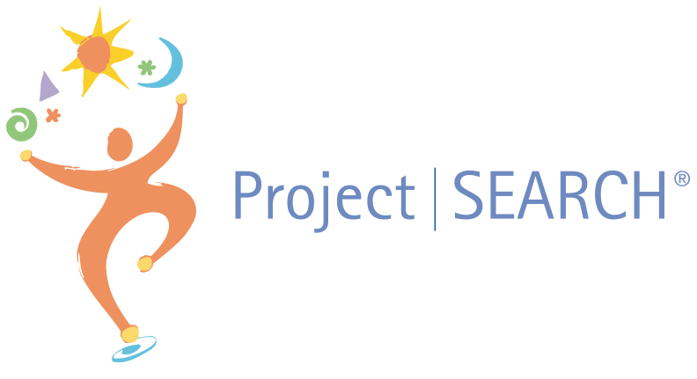

Mentor Guide

Dear Mentor,
On behalf of Norse Project SEARCH, we thank you for your willingness to participate in our program. We realize that a mentorship takes time and energy, and your support is what makes our program possible.
Interns who are mentored through Project SEARCH benefit in multiple ways. They gain knowledge and marketable job skills that assist in getting paid jobs in our local community. They develop increased self-confidence, motivation to gain employment, an increased sense of responsibility, and an overall increased quality of life.
As a mentor, we hope that you experience the benefits of mentoring an intern. As Shawn Hitchcock stated, “A mentor empowers a person to see a possible future, and believe it can be obtained.”
Thank you for taking the time to make a difference in our program and the lives of our interns. We want your mentoring experience to be a meaningful and positive experience for you. Please contact us at any time if you have questions, concerns or successes. Thank you for your commitment!

Respectfully,

The Norse Project SEARCH Staff

Project SEARCH Staff Contact Information:

Project SEARCH Instructor: Lindsay Heiert
Mobile Phone: 859-630-9280
Office Phone: 859-572-7923
Email: lindsay.heiert@campbell.kyschools.us or beckerl3@nku.edu

Project SEARCH Skills Trainer: Abby Paiotti
Mobile Phone: 859-739-0776
Email: abby.paiotti@bawac.org

Project SEARCH Skills Trainer:
Mobile Phone:
Email:

Project SEARCH Overview
Project SEARCH is an internationally recognized program dedicated to building a workforce that includes people with disabilities. Its business partnerships benefit the individual, the community and the workplace. The program was established in 1996 at Cincinnati Children’s Hospital Medical Center to address staff turnover in entry-level support positions by actively recruiting candidates with intellectual and developmental disabilities. The successful model has been replicated in hospitals, banks, universities and businesses in more than 500 locations in the U.S. and abroad.
Designed as a nine-month unpaid internship program, Project SEARCH places interns in real-world work settings where they learn all aspects of gaining and maintaining employment. A series of three internships lasting 10-12 weeks allows interns to explore careers and develop marketable job skills. They receive support from department mentors, skills trainers, and worksite accommodations and adaptations. The ultimate goal is for each intern is to secure competitive employment within their community. The program offers individualized job development, which is based on the intern’s experiences, strengths, and skills.

What is a Project SEARCH Mentor?

A mentor is an experienced individual that serves as a trusted counselor, loyal adviser and coach who helps and guides another individual’s development. The mentor is a confidant who provides perspective, helps the intern reflect on the competencies they are developing, and provides open, candid feedback. Mentors have a unique opportunity to serve as a “sounding board” for an intern on issues and challenges. Mentors are people who are interested in and willing to help others.
Ways to Mentor Interns:
- Be intentionally inviting (let the intern know you are glad they are here):
- With words: “I’m glad you are here.”
- Through introduction to other staff members
- By providing a place to hang their coat and a place to work
- Through inclusion in staff socials, meetings, etc., when appropriate
- By getting to know the intern and their interests and goals.

- Establish a structure and basic working rules for your relationship or your worksite (both written and unspoken rules).

- Give frequent positive feedback on things the intern is doing correctly as well as feedback for needed improvements. You have a powerful influence on the intern with such issues as appearance, personal hygiene, communication, and personal habits. A Project SEARCH staff member will provide you with an easy to use evaluation form.

- Participate in your intern’s employment planning meetings to provide feedback on his or her performance and suggestions for improvement.

Guidelines for Orienting Interns to Your Worksite
Be sure to sit down with your intern at the start of their internship and lay out your expectations for their participation in your work area. You may want to put your expectations in writing. Some items you may want to discuss are:

- TIME: (arrival, departure, break times, etc.)
- DRESS: (what is appropriate for your work environment)
- WORK EXPECTATIONS: (describe the work the intern will do, how to do it, and where to get assistance if they have a question.)
- Where to place their personal belongings.
- Unique RULES of your worksite (both obvious and unwritten).
- Procedure for notifying you when absent.
- Procedure for times when you may not be present to directly supervise the intern (list of tasks to do; someone to whom to report).
Mentoring Tips:

- Talk to the intern as any other new employee.
- Keep it Simple - Give Concrete, specific, short instructions and check for understanding.
- Utilize the Skills Trainer for additional training or problem solving.
- Add new tasks as the intern masters tasks.
- Have high expectations for the intern.
- Empower rather than solving problems.
- Share your work expertise.
- Enjoy the experience!

Attributes to Effective Feedback:
- Specific, not general
- Factual not opionionated
- Shared information, instead of advice
- Descriptive not judgemental
- Is clearly understood by the intern (check for understanding)
- Based on mutual rapport and trust
- Timed to be most useful
- Sensitive to intern’s feelings and needs
- Allows for intern’s perspective
- Constructive, not destructive
- Communication should be directed at behavior not at personality
- Leads to positive outcomes
Disability Awareness Tips:
- When talking to a person with a disability, look at and speak directly to that person rather than through a companion or interperter.
- When refering to a person with a disabilitiy, make reference to the person first, then the disability. Use terminology such as “a person with a disability” rather than a disabled person.
- Treat adults as adults. Address people with disabilities by their first names only when extending that same familiarity to all others.
- ASK FIRST - If you offer assistance, (always ask before assisting someone), then wait until the offer is accepted. Then ask the individual with a disability for instructions on how you may assist them.
- RELAX. Don’t be embarrassed if you happen to use common expressions such as “see you later” for a blind person or “Did you hear about this?” for a person who is deaf or hard of hearing.
- Listen attentively when speaking with a person with a speech impairment. Keep your manner encouraging rather than correcting. Never pretend to understand if you are having difficulty understanding. It is acceptable to ask the person to repeat him or herself.
- Do not assume that because someone has a cognitive impairment, such as a learning disability, that s/he has below-average intelligence. The individual may have above-average intelligence, but may have difficulty receiving, expressing, or processing information.
- Ask the person if s/he prefers verbal, written, or hands-on instruction, or a combination of methods in training and work-related situations. For example, if providing verbal instructions, it may be helpful to follow-up with an e-mail that clarifies your request.
- Be patient. Allow the individual time to think and answer questions independently.

Project SEARCH Calendar
Norse Project SEARCH
2022-2023 Student Calendar and Important Information
Important General Calendar Dates
August 10th, 2022 – First Day for Interns at Norse Project SEARCH
September 5th, 2022 – Labor Day
September 23rd, 2022 – District Planning Day – Interns off
October10th – 14th, 2022 – Fall Break
November 8th, 2022 – Election Day – Interns off
November 23rd – 25th , 2022 – Thanksgiving Break – Interns off
December 22nd, 2022 – January 3rd, 2023 – Winter Break – Interns off
January 16th, 2023 – Martin Luther King Jr. Day – Interns off
February 20th, 2023 – District Planning Day – Interns off
March 23rd & 24th, 2023 – District Planning Days – Interns off
April 10th – 14th, 2023 – Spring Break – Interns off
May 16th, 2023 – Election Day – Interns off
May 19th, 2023 – Last Day for Interns at Norse Project SEARCH

Internship Information (3 Internship Rotations)
Internship Rotation 1 Dates: (August 22, 2022- November 11, 2022)
Internship Rotation 2 Dates: (November 21, 2022 – February 17, 2023)
Internship Rotation 3 Dates: (February 27, 2023 – May 19, 2023)

Project SEARCH Daily Schedule:
Monday–Friday 7:45am -2:30pm
7:45 –8:45 Employability Skills Class: Lessons (in the designated training space) are based on the approved Project SEARCH curriculum and include daily living and employability skills (i.e. problem solving, team work, decision making, budgeting, nutrition, resume writing, and interviewing techniques).
9:-11:00 Internship Sites: Interns participate in non-paid internships throughout the host business. They rotate through three different internships during the program.
11:00-11:30 Lunch: Interns may purchase a lunch from the cafeteria or pack a lunch. Interns are encouraged to have lunch wherever it is appropriate, either with their peers or at their internship sites.
11:30-1:30 Internship Sites: Interns return to their sponsoring departments to continue learning job-specific skills.
1:30-2:15 Classroom Reflection/Planning/Communication Skills: Interns debrief with the Project SEARCH Instructor and skills trainers at the designated training space, and then take public transportation home.

Thank you for sharing your knowledge with a Project SEARCH Intern and helping them to achieve the goal of employment in the community!

