CSC 501 Homework #6
Due Date: Wednesday, April 15

- Show the 2-3-4 tree created by inserting the following values in the order given:
10, 20, 30, 40, 50, 60, 70, 80, 90, 100, 110, 120, 130, 140, 150

- Repeat #1 with the following values:
80, 40, 100, 70, 30, 10, 90, 140, 20, 110, 60, 150, 120, 50, 130

- Draw the following red-black tree as a 2-3-4 tree. The dotted lines indicate red children.
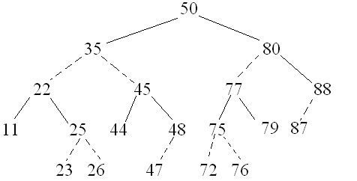
- Draw the following 2-3-4 tree as a red-black tree using dotted lines to indicate red children.
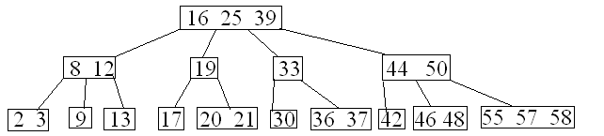
- We want to store 10,000 values in a height balanced tree. What is its minimum and maximum height if these values are stored in a non-height-balanced binary tree? A 2-3 tree? A 2-3-4 tree? A red-black tree?

- In general, a B-tree of order K is a height-balanced tree where each node in the tree can store up to K-1 data values with K pointers. For instance, if the node currently has 6 data then the node has 7 children. In question 5, you should be able to see that the height of a 2-3-4 tree will be shorter than a 2-3 tree which will be shorter than a height-balanced binary tree, at least when the number of nodes is suitably large enough. NOTE: B-trees are actually used to store large collections of data where much or all of the data is stored on disk. But consider creating a B-tree of order K in place of our height-balanced binary tree, 2-3 tree or 2-3-4 tree.
  - If we have to store N data, why not create a B-tree of order K = N?
  - Is there some value K where we have the optimal number of operations when searching or inserting? If so, what is that value?

