CSC 501 Programming Assignment #7
Due Date: Friday, May 8

You will implement part of the Network ADT. You may use either an adjacency matrix or an adjacency list although the matrix is recommended. Specifically, your network will represent highway mileage between major US cities (see the figure below). Your data structure will have to represent each city as a node in the network and the various edges as shown in the figure. For each edge, you will store the distance (in miles) between the two cities. If you select the adjacency matrix, use some special value (such as -1) to indicate when no edge exists between two nodes. Because your adjacency matrix or list will be indexed by integer values (such as network[5][8]) but the data contains city names (Strings), you will need an additional data structure. Use a one-dimensional array of Strings whereby city[i] stores the name of the city located in network[i] (adjacency list) or network[i][*] (the row of the adjacency matrix). City names should be stored in order in the one-dimensional array. If you are to add or delete a city, this will require not only shifting names in the one-dimensional array, but also in your adjacency matrix or list.

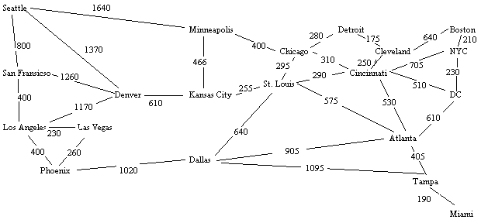

Your ADT will require operations to add a node, delete a node, add an edge, delete an edge, generate a depth-first traversal from a given node, generate a breadth-first traversal from a given node, and find the shortest distance path between two cities (using Dijkstra’s algorithm). For the breadth-first traversal, you will need a queue.

When invoking your operations, you should pass to the network object the message and the cities by name rather than index. For instance, if your network object is called n, then n.depthFirst(“Cincinnati”) or n.shortestPath(“Cincinnati”, “New York City”). In addition, you should have a constructor that receives an int value that specifies the maximum number of nodes in the network (create your adjacency matrix to be of size [max][max] or your adjacency list to be of size [max]).

Run your program on the commands placed in the two data files on my web site. These files will assume that you have called your methods addNode, deleteNode, addEdge, deleteEdge, depthFirst, breadthFirst, and shortestPath. You will have to edit the two data files if you have a different implementation.

