Improper Integration Handout

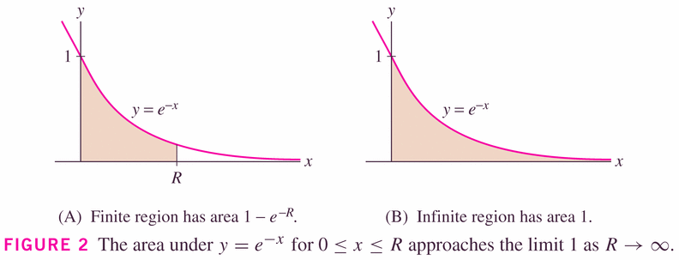

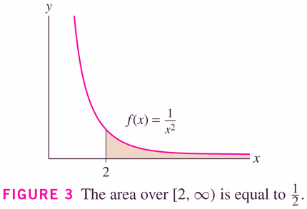

This figure illustrates two kinds of improper integrals, actually. The region in grey, and the region in white. Let’s see if either is defined (claim is that the grey one exists, and ½).

#13, p. 464

#12, p. 464

#43, p. 464

