Here is a snippet from an article originally published in the American Math Monthly by R. Creighton Buck:

Sherlock Holmes in Babylon: and other tales of mathematical history
By Marlow Anderson, Victor J. Katz, Robin J. Wilson

http://books.google.com/books?id=BKRE5AjRM3AC&printsec=frontcover

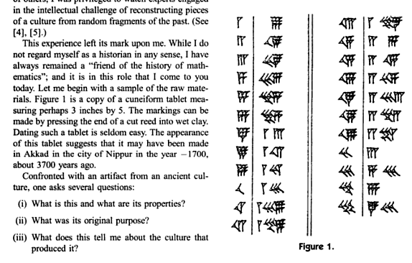

Your job, given your reading of section 1.3: Attempt to answer those questions!

