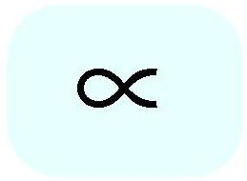

**PROPORTIONALITY**

Derrick O’nan

In mathematics, two variables are proportional if a change in one is always accompanied by a change in the other. I chose this mathematic symbol because I believe it reflects our relationship with the planet we call home, Earth and the countless number of inhabitants it contains that we come across on a day to day basis.

In our respective lives we all go through changes, some small and hardly noticeable while others are monumental in altering the course of our lives (Hopefully for the better). In any case these changes will have ripple effects on the ones closest to us thus one change being accompanied by another.

That being on a more personal level, globally there’s proportionality as well. Our way of living has a direct influence on the structure of our planet and environment, as we advance/grow as a society more buildings, highways, and homes are built changing the Earth’s landscape forever. Advancing as a civilization isn’t all positive however; certain lifestyle choices and resources we use/abuse can have harmful ramifications on our planet we call home making us proportional with Earth and vice-versa.