Clayton Frink

MAT 375

4/29/18

Final Model Fit to City: Niamtougou

In setting the global model for all of Togo to Niamtougou, I was unable to make the model continuous after adding the ENSO and SST predictors to the model. Since the ENSO and SST data were individual points of data, I could not figure out how to make the previous continuous model stay continuous with the newly introduced ENSO and SST data, given the new model introduced discrete values at given times from 1961 to 2015. The models for the maximum temperature, minimum temperatures, and rainfall models (shown in red) and the actual data values collected by the Togolese (shown in blue) will be shown and talked about below.

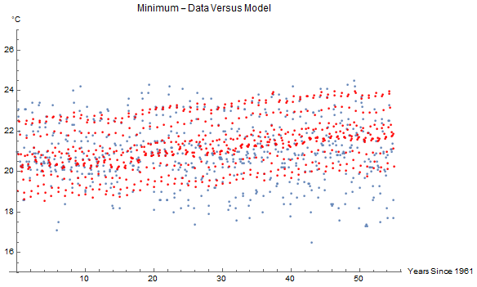

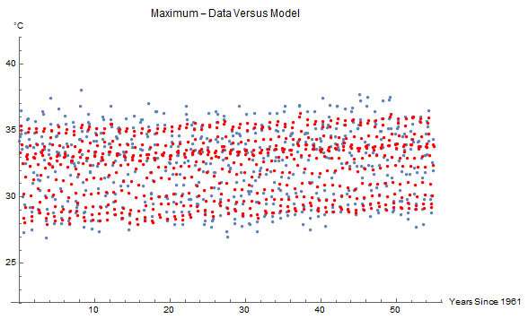

The maximum temperature model seems to be tracking along with the increasing temperatures as time increases, however, the minimum temperature model does not see the same increase in temperature over time. This may be cause for some alarm, seeing as if this pattern of steady increase in the maxima temperature continues in Niamtougou, the wildlife could be adversely affected with an increasing range of temperatures.

The location of Niamtougou could also contribute to the anomaly of a gradual maximum temperature increase and a minimum temperature stagnation. Winds were not part of this study, but they might be adding extra variation, with the Togo Mountains running longitudinally through West Africa and cutting through the middle of Togo. Niamtougou is nestled directly to the East of The Togo Mountains, which may play a role in diverting wind currents.

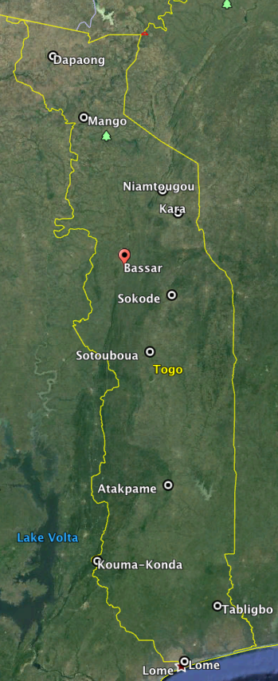

Niamtougou recieves more rain than at least half of the other cities in Togo, which can be noted by several points in the graph, "Rainfall- Data Versus Model." These points exceed that of the overall rainfall model for Togo. Justification for this trend found in Niamtougou could also be contrived by The Togo Mountains to the West

