Section 1.4 – The Derivative as a function Name____________________

1. If *f* is represented by the following table, fill in the missing rows on the table.

|  |  |  |  |  |
| --- | --- | --- | --- | --- |
| *x* | 0 | 2 | 4 | 6 |
| *f(x)* | 4 | 6 | 7 | 6 |
| *(a,f(a)* ),(a+h, f(a+h) ) to approximate *f’.* |  |  |  | Leave blank |
| *f’(x)* |  |  |  | Leave blank |

1. Given the following graph of *y = f(x),* draw the approximate graph of *y = f’(x)*.

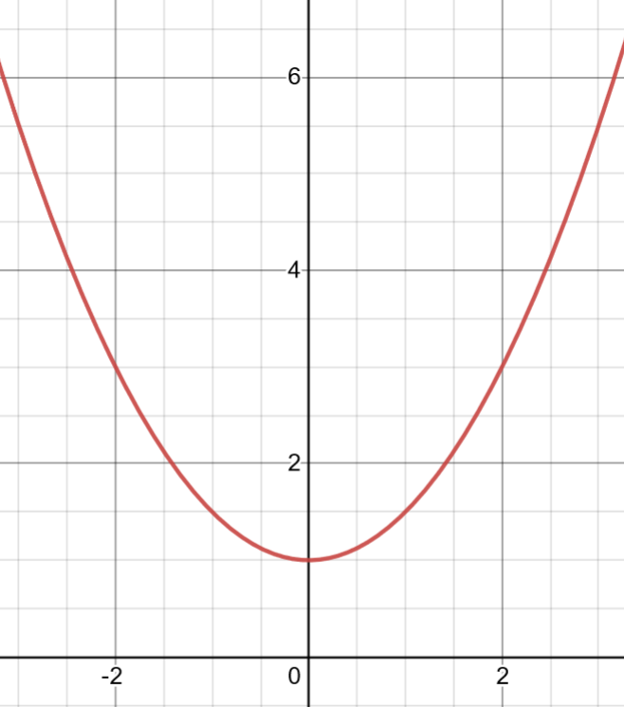

1. Given that , use the algebraic definition to find a formula for *y = f’(x). Show all of your work!*
2. If *f* is represented by the following table, fill in the missing rows on the table.

|  |  |  |  |  |
| --- | --- | --- | --- | --- |
| *x* | 0 | 0.5 | 1 | 1.5 |
| *f(x)* | 3 | 2 | 4 | 8 |
| *(a,f(a)* ),(a+h, f(a+h) ) to approximate *f’.* |  |  |  | Leave blank |
| *f’(x)* |  |  |  | Leave blank |

1. Given the following graph of *y = f(x),* draw the approximate graph of *y = f’(x)*.

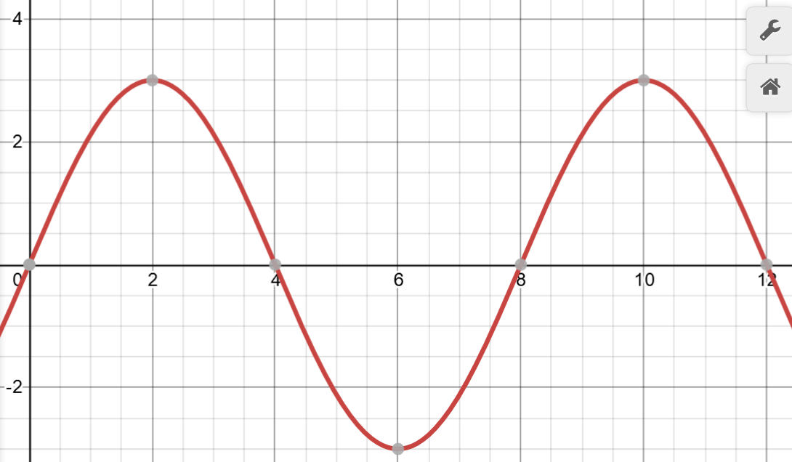

1. Given that , use the algebraic definition to find a formula for *y = f’(x). Show all of your work!*
2. If *f* is represented by the following table, fill in the missing rows on the table:

|  |  |  |  |  |
| --- | --- | --- | --- | --- |
| *x* | 0.1 | 0.2 | 0.3 | 0.4 |
| *f(x)* | 1.1 | 0.7 | 1.0 | 1.3 |
| *(a,f(a)* ),(a+h, f(a+h) ) to approximate *f’.* |  |  |  | Leave blank |
| *f’(x)* |  |  |  | Leave blank |

1. Given the following graph of *y = f(x)* draw the approximate graph of *y = f’(x)*

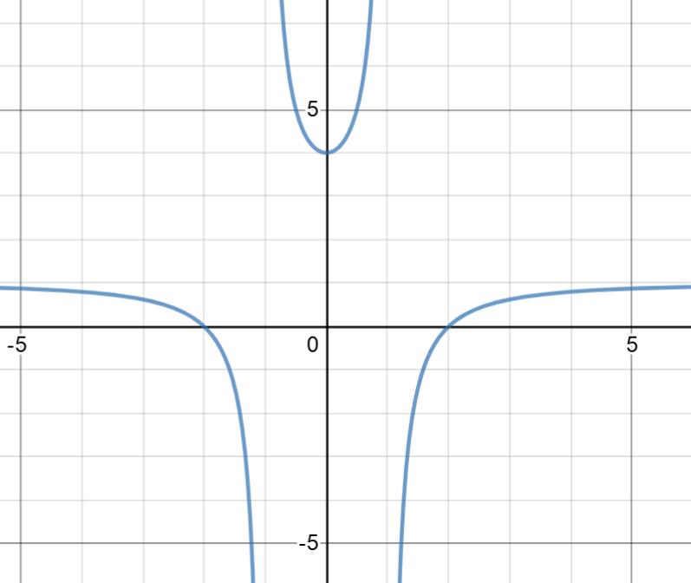

1. Optional: Given that $y=f(x)=4x^{3}+3x^{2}$, use the algebraic definition to find a formula for *y = f’(x). Show all of your work!*