Dominik Gardner

April 20, 2024

Mathmalchemy project

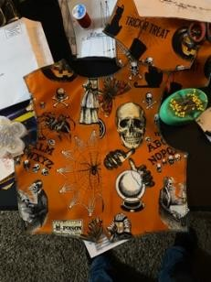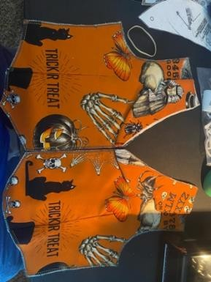

“The Symmetry Shoppe” Boy’s Vest

Girl’s Peasant Dress

1880’s Men’s Corset

For my project I chose to use my sewing skills and costume construction skills to construct three different mini projects, a girls’ peasant dress, a boys’ vest, and a Victorian mens’ corset.

In costume design and art, we use symmetry a lot, especially in costume design because the human body has reflective symmetry and not rotation symmetry; however, when constructing costumes and clothes we sometimes use rotational symmetry along with reflective symmetry, as seen in the peasant girl dress. The gathered layers of the dress are essential cut circles, that you can turn and not know it had turn if it wasn’t for the pattern, so we can ignore the pattern for now.

The use of pattern symmetry is another way costume and fashion designers use symmetry as easily seen in the boys’ vest and in the mens’ corset, although the pattern is easier on the eyes to recognize in the boys’ vest. We can see that the same images on both the left and right front facing pattern pieces, showing that they both have symmetry, however the collar does not because we see a different part of the pattern.

This is because as I was cutting the pattern, I wanted to change the layout of the pattern to create an asymmetrical look around the collar and break up the space of pattern so it wouldn’t become stale and rigid.

It is harder to see the pattern in the corset unless you are going over it with a fine-tooth comb, but the way I cut the fabric was meant to create a symmetrical look because the main idea of corsets is the symmetry they have, which is reflective.

The power of symmetry in costume design is both a blessing and a curse because as humans we easily pick up on symmetry and love it. We use symmetry to create compelling and amazing characters, the protagonist is usually design symmetrically, while the antagonist or character we (designers) want you to be weary of, will create asymmetrical designs for to give you a feeling of them being skewed as well as create an off-putting feeling for you as an audience.

We also see symmetry in the visual arts, a great example of this is *Jan Van Eyck's Ghent Altarpiece,* (<https://www.thoughtco.com/definition-of-balance-in-art-182423> ). The piece has symmetrical balance and radial symmetry as shown by the dove acting like a circle with the golden rays as a spoke pointing to the figures worshipping Christ (the lamb), the rays are symmetrically spaced, this is radial symmetry. The overall symmetry of the piece can easily be seen in the balancing of the composition with the figures separated by the fountain in equal number, creating a nice harmonious balance.

The is also balance found in the two groups of people being contrasted by the people at the top of the composition, this creates a pin wheel like composition of the groups of people, which helps to invoke the harmony Jan Van Eyck wanted to depict the importance of Christ, and the worshipper’s exaltation of him.

I chose to write a quick art analysis because my other degree is in art history, and I discuss symmetry all the time within the visual arts.

I think a section of Mathmalchemy should have a little shop called ‘The Symmetry Shoppe’, where examples of symmetry in clothing, design and art are displayed because we use them in the visual and performative arts all the time, and it directly effects viewers in a easy, flashy way they can understand and grasp.