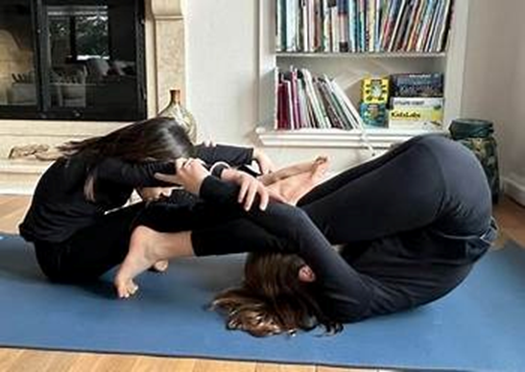

|  |
| --- |
|  |
|  |
|  |

|  |  |
| --- | --- |
| [Two girls sitting on a mat  Description automatically generated](https://kidsyogafun.com/partner-yoga-poses-for-kids-and-teens/) | |
| [kidsyogafun.com](https://kidsyogafun.com/partner-yoga-poses-for-kids-and-teens/) | |
| [Two people doing yoga in a room  Description automatically generated](https://kidsyogafun.com/partner-yoga-poses-for-kids-and-teens/) |
| [kidsyogafun.com](https://kidsyogafun.com/partner-yoga-poses-for-kids-and-teens/) |
|  |

|  |
| --- |
| [A person standing on one leg and holding her hands up  Description automatically generated](https://kidsyogafun.com/66-easy-animal-yoga-poses-for-kids/) |
| [kidsyogafun.com](https://kidsyogafun.com/66-easy-animal-yoga-poses-for-kids/) |

|  |
| --- |
| [A person sitting on a yoga mat  Description automatically generated](https://kidsyogafun.com/66-easy-animal-yoga-poses-for-kids/) |
| [kidsyogafun.com](https://kidsyogafun.com/66-easy-animal-yoga-poses-for-kids/) |