Taylor's theorem and Taylor series expansions have wide-ranging applications in various fields of mathematics, science, and engineering. Here are some areas where Taylor's theorem is commonly used:

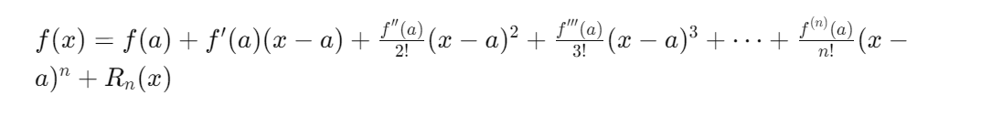

1. Approximation of Functions: Taylor's theorem provides a method to approximate a function with a polynomial near a point. This is useful in numerical analysis and computational mathematics for simplifying complex functions and making them easier to work with.

Consider the function 𝑓(𝑥)=sin(𝑥). We know how to and want to approximate sin(x) using a Taylor series around 𝑥=0(also known as a Maclaurin series). The Taylor series representation for this function is:



Then, what should we do?? Yes, do the derivatives of Sin(x) at x=0. It is:

**F(0)=sin(0)=0**

**F’(0)=cos(0)=1**

**F’’(0)=-sin(0)=0**

**F’’’(0)=-cos(0)=-1**

**……**

**Then we can start to build the Taylor series close to the sin(x)**

**1, f(x)≈x 2, f(x)≈x+0*x^2 3, f(x)≈x-x^3/3!=x-x^3/6……**

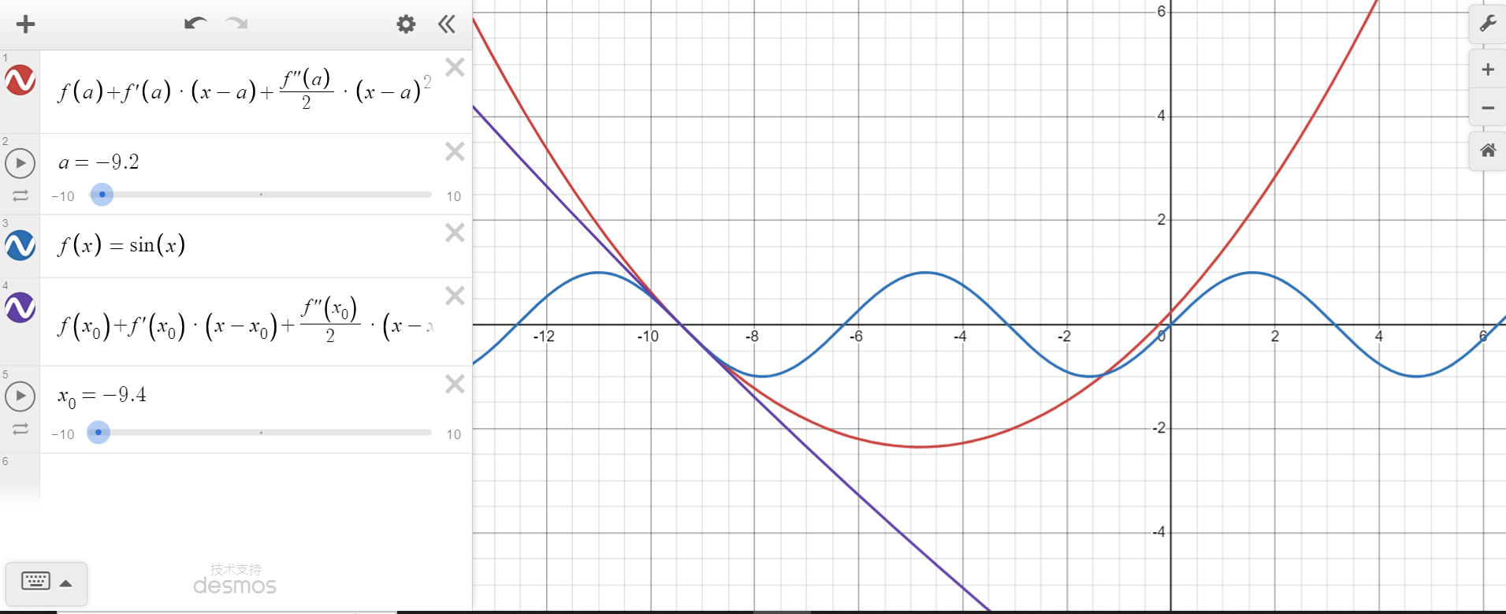

**Now, let’s see next of Tylor theorem.**

2.**Numerical Calculations: Taylor series expansions are used in numerical methods such as finite difference approximations and numerical integration. They provide a way to approximate functions and perform calculations efficiently.**

**Let us give an example to illustrate. For example, we want to approximate an exponential function：**

**The general formula for the Taylor series expansion of a function: f(x) about x=a is :**

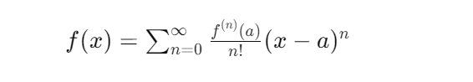

**Where f^(n) (a) represents the *n*th derivative of f(x) at x=a.**

**Thus, for all derivatives are e^x when x=0, e^0= 1. We can write it looks like:** 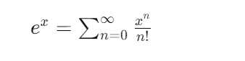

**If we want to do the Numerical Calculation, what should we do? Yes, use the first four terms of the Taylor series to approximate the e^x.**

**0th: (1/0!)*1^0=1**

**1st: (1/1!)*1^1=1**

**2nd:(1/2!)*1^2=0.5**

**3rd: (1/3!)*1^3=1/6**

**Then, add them together, got 1+1+0.5+1/6, close to 2.66666≈2.67=e^x**

**But, there is some same but different, I think we didn’t get it on class??**

**3. Where else can Taylor series be used, or in other formulas?**

**It can use on the** **Machine Learning and Optimization.**

**Machine Learning and Optimization: Taylor series expansions are used in machine learning and optimization algorithms for approximating objective functions and updating model parameters.**

**If we use octave to show that. We can get:**

% Sample data

x = [1, 2, 3, 4, 5];

y = [2, 4, 6, 8, 10]; % Linear trend for simplicity

% Polynomial regression: y = a + b*x + c*x^2

degree = 2;

X = [ones(size(x)); x; x.^2]'; % Polynomial features (Taylor series expansion)

% Using the normal equations to find the polynomial coefficients

coefficients = (X' * X) \ (X' * y');

% Predicting new values with the polynomial model

x_test = linspace(1, 5, 100); % Test data for plotting

y_pred = coefficients(1) + coefficients(2) * x_test + coefficients(3) * (x_test .^ 2);

% Plotting the results

plot(x, y, 'o', x_test, y_pred, '-');

title('Polynomial Regression');

xlabel('x');

ylabel('y');

this code will show us a graph with a line

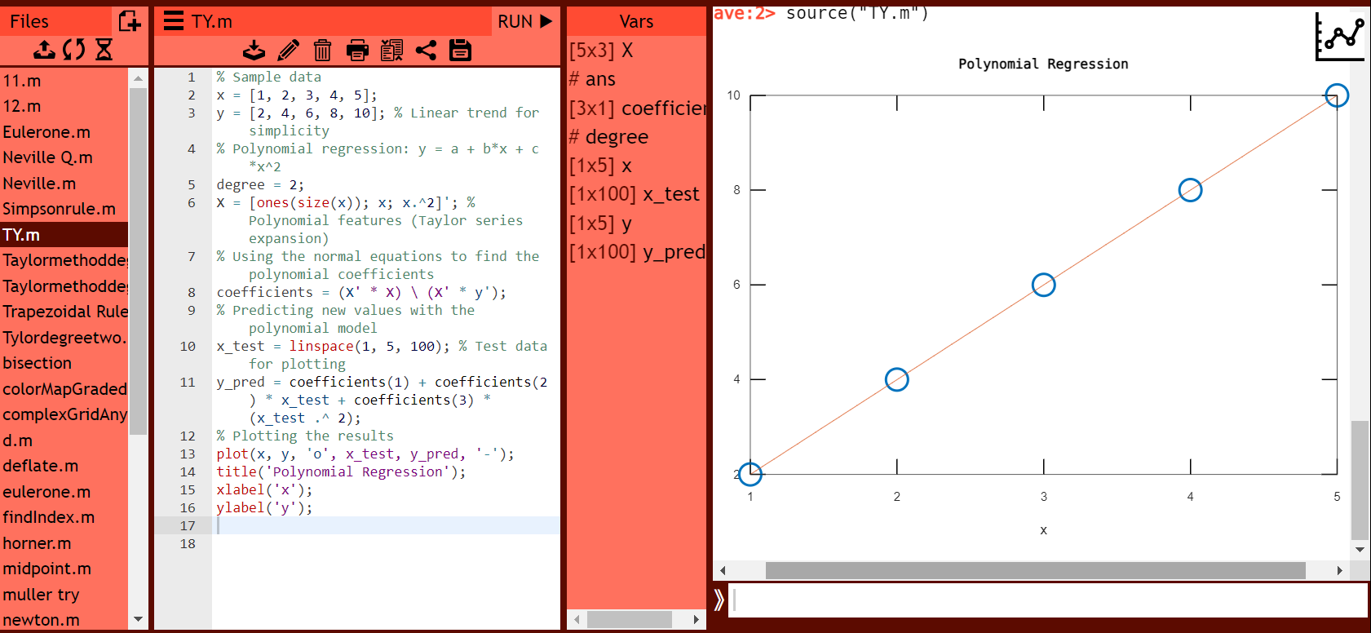

**If use function, it is:**



**The relationship between Taylor series and Newton's method**

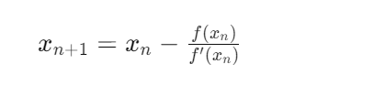 **this is Newton’s method.**

*f*(*x*)≈*f*(*x*0​)+*f*′(*x*0​)⋅(*x*−*x*0​)

0≈*f*(*x*0​)+*f*′(*x*0​)⋅(*x*−*x*0​)

*x*≈*x*0​−*f*′(*x*0​)*f*(*x*0​)​ **This is the expansion of the Taylor series, which we all know**.

**Thus, see the connection of these two.**



**Result:**

**Finding roots: Newton's method relies on first-order Taylor series, which makes it a popular algorithm for finding roots of functions quickly.**

**Optimization: By incorporating the second order Taylor series concept, Newton's method can be used to optimize neural networks and other machine learning applications.**

PDF:

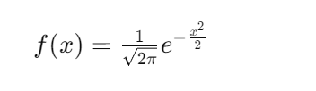

Suppose we want to approximate this PDF around a point 𝜇(the mean of the normal distribution) using a Taylor series expansion. We can expand the exponential term using the Taylor series:

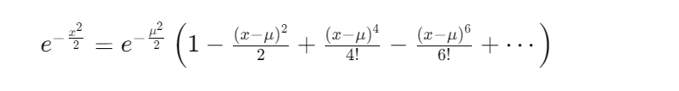Then, let us to see and explain this PDF:

