Destini Edwards

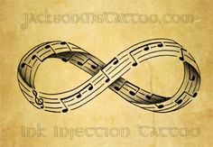

How it relates to me:

As a musician I often spend a lot of time playing, reading, or thinking about music. As my logo I wanted a an infinity sign made with music because that really embodies how I think and what I love to do, so this represents me as well as any logo could. It helps the matter that it looks like my old high schools fight song that I played for what felt like an infinity for those four years!

How it relates to math:

This is mathematical because just look at it, it’s infinity… A playable infinity, nevertheless it is still an infinity just of music that will carry on forever and ever… or just until people get tires of playing it!

DISCLAIMER!!!

This is not my work of art all credit goes to JacksonMsTattoo.com