Celtic Knot. Begin Anew.

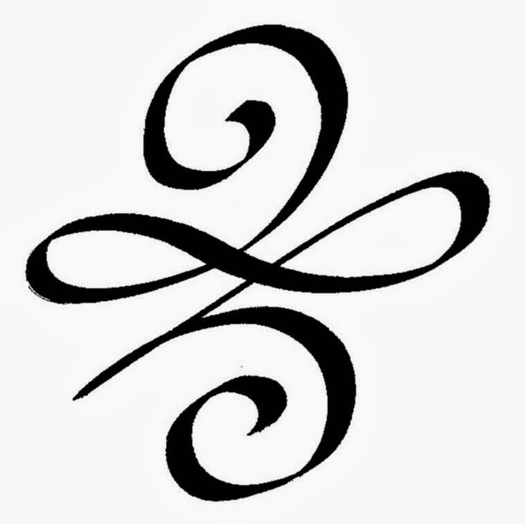

Taryn Walkerly

MAT 115

April 29th, 2015

Logo Design

I made my logo the Celtic Knot that means begin anew. I kind of use this symbol as a meaning in my life that there can always be a new beginning. To me this knot shows there is a beginning and ending, and life is a wild ride. I think of it as pinball maze, once you get to an end or a stop life shoots you back again. Essentially starting a new beginning with every shot.

This symbol relates to the course because it is an unknot and although it is the simplest knot, it is not completely irrelevant. It is the basis of all knots before they begin to form as links. Lets use this as an example, everyone’s life is a unknot, they have a beginning and end with the chance to start new in each chapter. When they meet someone else that they want to share their life with then they will form a different knot such as Solomon’s Knot, and be linked together for the rest of their life.

This unknot is twisted to make it appear to have an unconnected infinity sign twisted in it. Since it doesn’t connect we see how my symbol of life is not infinite, there is a beginning and end. I wanted a symbol that can’t relate to my life in the most realistic terms, giving a good reason for not having a continuous knots as well as a completely infinity sign. I enjoy how it represents that life isn’t infinite, it can’t go on forever and there is a lot of twists and turns along the way.