Packet 6: Chi-Square Test for Independence Textbook pages: 18 – 24; 624 – 631
After completing this material, you should be able to:
- calculate the expected count for any cell of a contingency table.
- find marginal distributions for a contingency table and use those to construct a side-by-side bar graph.
- compute chi-square contributions for any cell of a contingency table.
- conduct the chis-square test (with the aid of StatCrunch output) to determine if two categorical variables are related.

The legalization of medicinal marijuana has been a hotly contested subject. A survey conducted in April 2015 was undertaken to investigate whether a relationship exists between feelings on the legalization of medicinal marijuana (for/against) and political party (Republican/Democrat/Independent).
During this study, a total of 500 individuals were surveyed. For each American adult, what variables were recorded? Are these variables categorical or quantitative?

Because two variables were recorded for each individual, we need a way to organize this data. A contingency table categorizes counts on two (or more) categorical variables – in other words, this table summarizes the number of individuals in all possible combinations of categories. We can summarize the responses to the survey in the table below:
 |  | Legalization of Marijuana
 |  | Supports | Does not support
Political Party | Democrat
 | Republican
 | Independent

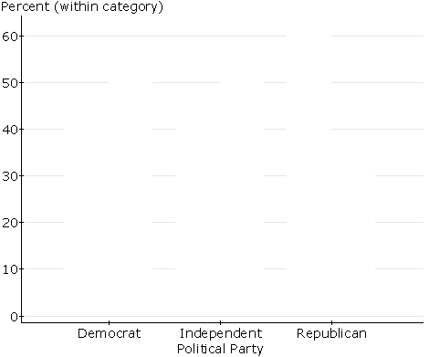
Instead of looking at the counts, let’s split the table into marginal distributions – that is, what percentage of each political party surveyed gave each of the two responses?

In order to determine if the differences are significant, we need to conduct a hypothesis test. One can never simply examine sample data and draw some conclusion about the population – we need to conduct a hypothesis test in order to determine if the results are significant.
What is the goal of the chi-square test for independence?

If we wanted to conduct this test on the legalization of marijuana data, what hypotheses would be tested?

In order to conduct a hypothesis test, we need some quantity to compare the observed counts from the survey to. This is referred to as the expected count (in other words, what should we have observed if the null hypothesis were true). Fill in the table below with the expected counts.
Observed  Counts |  | Legalization of Marijuana
 |  | Supports | Does not support
Political Party | Democrat | 116 | 84
 | Republican | 74 | 126
 | Independent | 59 | 41

Expected  Counts |  | Legalization of Marijuana
 |  | Supports | Does not support
Political Party | Democrat
 | Republican
 | Independent

What do you notice when the observed (top table) and expected counts (bottom table) are compared?

The test statistic for the chi-square test for independence compares the observed and expected counts. Its formula is the following:
Formula Alert!!
This formula will be given on the formula sheet.

Let’s look at how this test statistic is calculated by going back to the marijuana example:

What is the Chi-Square distribution?
In statistical inference, there are several common distributions used for inference. In addition to the normal distribution (which we have already used), the chi-square distribution is also a common distribution used for inference.
How is the chi-square distribution used to find a probability?

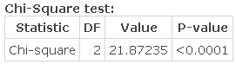
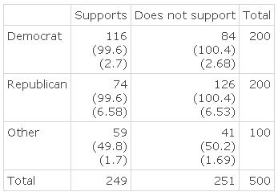
In general, we won’t calculate the chi-square test statistic (the calculation can be tedious) or the p-value associated with the test. Instead, we will rely on StatCrunch output for our calculations. Let’s look at the StatCrunch output for the legalization of marijuana example:

Complete the appropriate hypothesis test using a significance level of 0.05 to determine if political party and support of legalization of marijuana are related.

Example: All new drugs must go through a drug study before being approved by the FDA. A drug study typically includes clinical trials whereby participants are randomized to receive different dosages as well as a placebo. To control as many factors as possible, it is best to assign participants randomly across the treatments. A recent study for a new drug consisted of two dosages (10mg, 20mg) and a placebo. Those who designed the study would like to know if the dosage assigned was related to the participants’ gender. The responses are summarized in the StatCrunch output below:
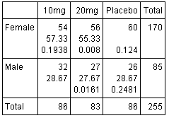
Compute the expected number of females receiving the placebo. What does this quantity mean?

Find the marginal distribution for each gender by filling in the tables below.
Based on these distributions, do you believe gender is somehow related to dosage? Explain.
 | Dosage
 | 10mg | 20mg | Placebo
Female

 | Dosage
 | 10mg | 20mg | Placebo
Male

Compute the chi-square contribution for male participants who were given 10mg of the drug.

Using the StatCrunch output below, conduct the appropriate test to determine if there is a relationship between gender and the dosage received. Use a significance level of 0.01.
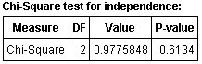

What assumptions must be satisfied for the chi-square test of independence to be valid?

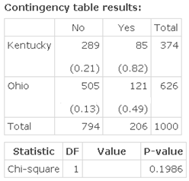
Example: A sample of 1000 traffic crashes occurring in either Kentucky or Ohio was selected from the National Highway Safety Traffic Administration database. For each crash, it was noted whether or not alcohol was involved in the accident. A reporter has questioned whether there is a relationship between alcohol involvement and the state in which the accident occurred. The information gathered is summarized in the StatCrunch output provided.
- Compute the number of accidents one would expect to involve alcohol in KY if there is no relationship.

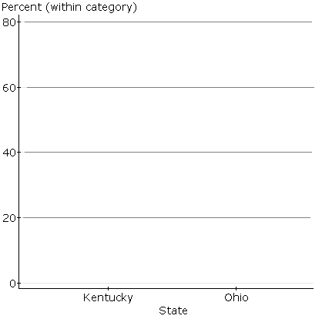
- Fill in the tables below with the marginal distributions for each state. Then create a side-by-side bar graph comparing the percentages for the two states.
 | Alcohol – yes | Alcohol – no
KY

 | Alcohol – yes | Alcohol – no
OH

- Conduct the appropriate test to address the conjecture made by the reporter. Use a significance level of 0.05.

