Packet 9: One-Sample Hypothesis Test for the Population Mean Textbook pages: 586 – 589; 597 – 601
After completing this material, you should be able to:
- conduct a test of hypothesis for µ using the appropriate format.
- state when it is valid to use this procedure.
- define Type I and Type II errors in terms of the problem.
- discuss the consequences of these errors.
Recall: What are the steps in a hypothesis test?

Example: The Flying Pig Marathon is held in Cincinnati every May. The StatCrunch output below summarizes the time it took for all runners in 2012 to finish the 26.2 mile race. An organizer of the marathon plans to sample 35 finishers from 2016 to see if the time it takes to complete the race has changed.
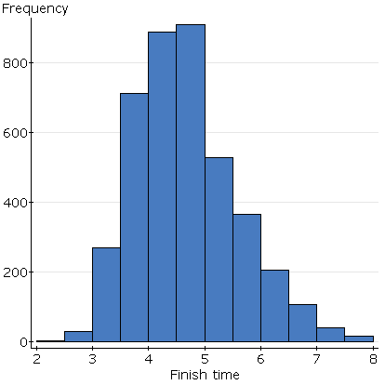

Describe the sampling distribution of the sample mean finish time when samples of 35 runners is taken.

The sample of 35 runners is taken and the sample mean is found to be 4.569 hours. Use the sample to test the claim made by the organizer at a significance level of 0.05.

Example: A city has instituted an educational program that they hope will reduce the number of violent crimes committed in the city. The program is quite expensive, so the mayor wants to be sure that it is worthwhile. In the past, the city experienced 5.2 violent crimes per day, on average. After implementing the program, a random sample of 36 days yielded an average crime rate of 4.7 violent crimes with a standard deviation of 4.16. Test the appropriate hypotheses to see if the program is successful at reducing violent crimes using a significance level of 0.10.
What variable was recorded? What parameter will be tested?

What hypotheses should be tested?

Assign the appropriate notation to the values given in the problem.

Problem!!

What is the effect of replacing σ with s?

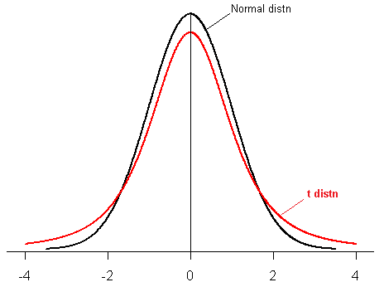
How is the t-distribution different than the normal distribution?

Technically we would need to use a t-table to find probabilities associated with the t-distribution. Because the t-distribution is indexed by its degrees of freedom, it is impossible to have a single table of these probabilities. Instead of using a table to find probabilities, we’ll rely on StatCrunch to calculate these probabilities.
Let’s look at a couple of examples of p-values to refresh how the probabilities are found:
Suppose we are testing the following null hypothesis, H₀: µ = 5, and the test statistic calculated is t = 2.74. For each of the three alternatives below, draw a picture representing the p-value for the test:
H_{a}: µ ≠ 5
H_{a}: µ < 5
H_{a}: µ > 5

Suppose we are testing the following null hypothesis, H₀: µ = 12000, and the test statistic calculated is t = -0.42. For each of the three alternatives below, draw a picture representing the p-value for the test:
H_{a}: µ ≠ 12000
H_{a}: µ > 12000
H_{a}: µ < 12000

What patterns do you notice in the calculation of the p-values and the alternative hypotheses?

Back to the example: A city has instituted an educational program that they hope will reduce the number of violent crimes committed in the city. The program is quite expensive, so the mayor wants to be sure that it is worthwhile. In the past, the city experienced 5.2 violent crimes per day, on average. After implementing the program, a random sample of 36 days yielded an average crime rate of 4.7 violent crimes with a standard deviation of 4.16. Test the appropriate hypotheses to see if the program is successful at reducing violent crimes using a significance level of 0.10.
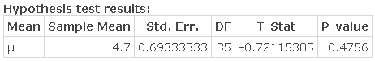
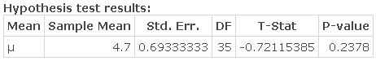
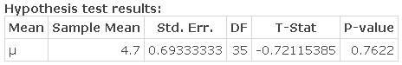

What type of error is possible in the hypothesis test which was conducted?

Example: Acetaminophen is an active ingredient found in hundreds of over-the-counter and prescription medicines, such as pain relievers, cough suppressants, and cold medications. It is safe and effective when used correctly, but there are consequences when too much or too little is taken. A researcher believes that the mean amount of acetaminophen per tablet in a particular brand of cold medicine differs from the claimed dosage of 600 mg. To investigate the claim, a random sample of 100 tablets is taken, and the average acetaminophen content was found to be 603.7 mg with a standard deviation of 9.782 mg.
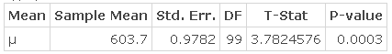
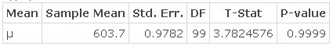
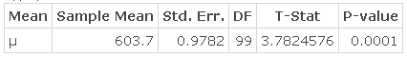

Example: A local business is considering a new location. A market analyst has determined that the location will have the greatest likelihood of success if the number of people who pass the storefront during the lunch rush averages 100 or more people. The storefront is observed for 25 weekdays.

What variable will be recorded?

What hypotheses should be tested in this study?

In the context of the problem, describe a Type I and Type II error. What could potential consequences be if these errors were to occur?

Remember that the significance level controls the probability of a Type I error occurring – based on your description, what significance level would you recommend setting?

A random sample of 25 days was taken, and the number of people passing by the storefront was recorded. The mean number of people who passed the store was 105.678 with a standard deviation of 18.932. Use these to test the hypotheses above at the significance level that was determined.
Possible p-values (only one is appropriate):
p-value = 0.1468
p-value = 0.0734
p-value = 0.9266

When the t-distribution is used for an inference, what assumptions must be satisfied?

