Packet 10: One-Sample Confidence Interval for the Population Mean Textbook pages: 589 – 596
After completing this material, you should be able to:
- construct a confidence interval for the proportion using the appropriate format.
- state when it is valid to use this procedure.
- explain what “confidence” means.
Bryan Price, the manager of the Cincinnati Reds, is interested in estimating the average attendance at home games. The attendance numbers reported for a sample of 40 home games in the 2016 season are summarized in the histogram and summary statistics below.
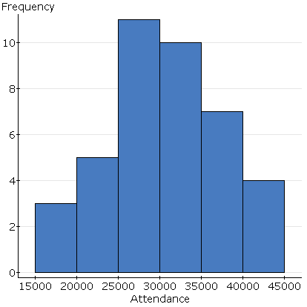
Referring to the summary statistics when appropriate, completely describe the distribution of attendance at home games using complete sentences.

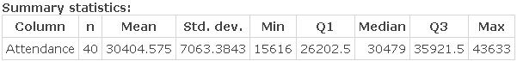

Find the interval that is two standard deviations from the mean. Interpret this interval (in context) using either the Empirical Rule or Chebyshev’s rule, whichever is most appropriate for this distribution.

Recall: What is a confidence interval?
Steps in a Confidence Interval

We want to develop a confidence interval which will be used to estimate the population mean. What will the formula for this interval be?

Back to the example: Estimate the mean home game attendance for the Cincinnati Reds with 95% confidence. Assume the appropriate critical point is 2.023.

Explain why the two intervals we have found differ.

Example: Hoping to lure more shoppers downtown, a city builds a new parking garage in the central business district. The city plans to pay for the structure using parking fees. During a two-month period (41 weekdays), daily fees collected averaged $126.50 with a standard deviation of $15.278.
- Estimate the mean amount of money collected from daily parking fees with 90% confidence.
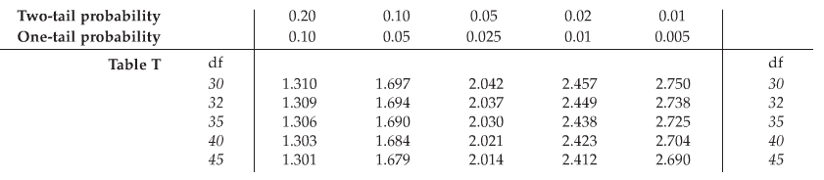

- The consultant who advised the city on this project predicted that parking revenues would average $130 per day. Based on your interval, do you think the consultant was correct? Explain.

- Suppose that for budget planning purposes, the city needs a better estimate of the mean daily income from parking fees. How can they get a better estimate?

Example: Prior to an advertising campaign, quality control experts working for Chips Ahoy needed to estimate the average number of chocolate chips in 18oz packages of cookies. To do this, a random sample of 16 bags of cookies were taken from the production line, and the quality control engineer counted the number of chocolate chips in the cookies in each bag.
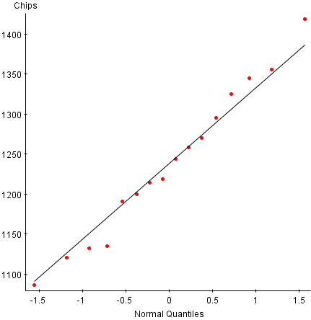
- Determine if the required assumptions are satisfied in order to estimate the mean number of chocolate chips in bags of Chips Ahoy cookies.

- The sample of 16 bags had an average of 1238.1875 chocolate chips with a standard deviation of 94.282 chips. Estimate the mean number of chocolate chips in 18oz packages of Chips Ahoy cookies with 95% confidence. If the estimate should not be calculated, explain why.
Note: One of the intervals given below is a 90% confidence interval, one corresponds to 95% confidence, and the final corresponds to 99% confidence.
Possible Intervals
(1187.9481, 1288.4269)
(1196.8672, 1279.5078)
(1168.7320, 1307.6430)

- In the 90s, Chips Ahoy aired a commercial claiming “1000 chips in every bag.” Comment on the validity of this commercial claim.

